**Safe use of pesticides**

Pesticidesaretoxictobothpestsandhumans.. Pesticide particles may be inhaled with the air while they are being sprayed.

Special precautions must be taken during transport, storage and handling. Spray equipment should be regularly cleaned and maintained to prevent leaks. People who work with pesticides should receive proper training in their safeuse.

# Precautions

## Thelabel

Pesticides should be packed and labelled according to WHO speciﬁcations (*1*). The label should be in English and in the local language, and should indicate the contents, safety instructions and possible measures in the event of swallowing or contamination. Always keep pesticides in their original con- tainers (Figs. 10.1 and 10.2). Take safety measures and wear protective clothing asrecommended.

## Storage and transport

Storepesticidesinaplacethatcanbelockedandisnotaccessibletounauthorized people or children (Fig. 10.3); they should never be kept in a place where they might be mistaken for food or drink. Keep them dry but away from ﬁres and out ofdirectsunlight.Donotcarrytheminavehiclethatisalsousedtotransportfood.

## Disposal

Left-over insecticide suspension can be disposed of safely by pouring it into a specially dug hole in the ground or a pit latrine (Fig. 10.4). It should not be disposed of where it may enter water used for drinking or washing, ﬁsh pondsor rivers.. In a hilly area the hole shouldbeonthelowersideofsuchareas.Pourrun-offwaterfromhandwashings andspraywashingsintothehole,andburycontainers,boxesandbottlesusedfor pesticides in it (Fig. 10.5). Close the hole as soon as possible. Cardboard, paper and cleaned plastic containers can be burned (Fig. 10.6), where this is per- mitted,farawayfromhousesandsourcesofdrinking-water.Forreuseofcleaned

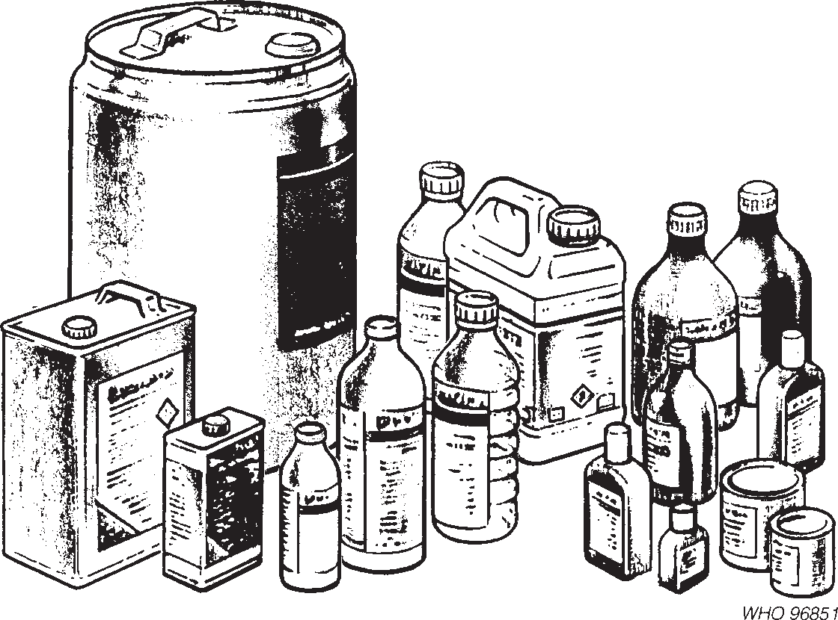

**Fig. 10.1**

Types of pesticide container (adapted from *2*).

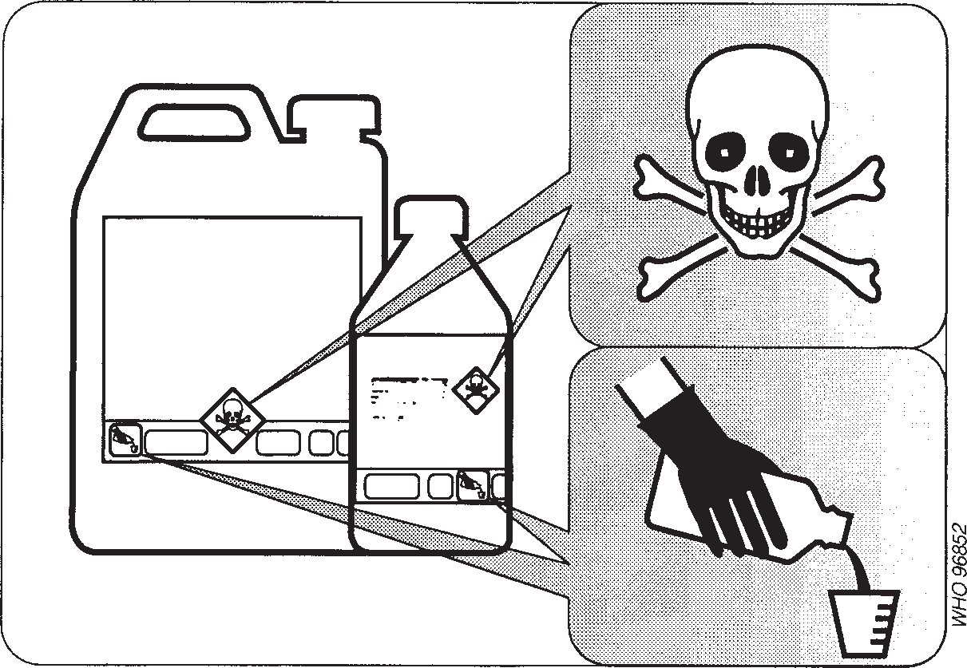

**Fig. 10.2**

Look for warning symbols, pictograms and colour coding on labels (adapted from *2*).

containers, see box (p. 388). Pyrethroid suspensions can be poured on to dry ground where they are quickly absorbed and degraded and do not causeenviron- mentalproblems.

Surplus solution can be used to kill insect pests such as ants andcockroaches. Pourorspongeitontoinfestedplaces(underkitchensinks,incornersofahouse).

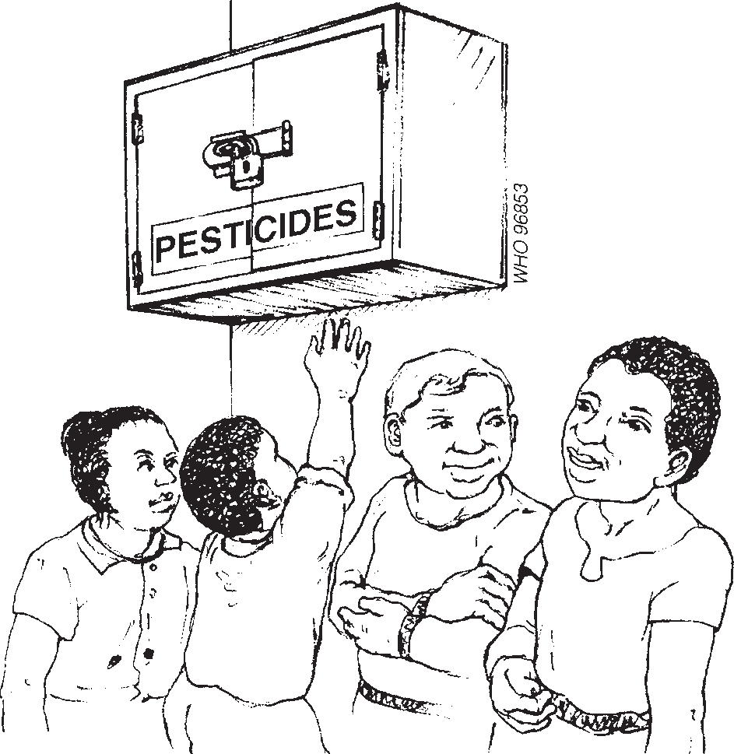**Fig. 10.3**

Keep pesticides out of reach of children (adapted from *3*).

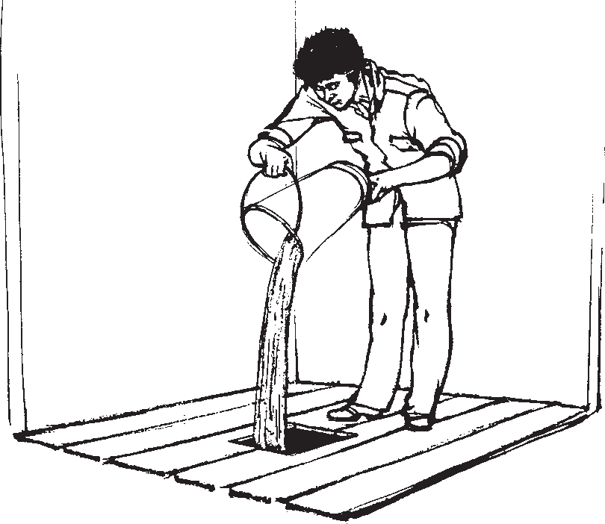**Fig. 10.4**

Surplus insecticide solution can be dis- posed of safely by pouring it into a pit latrine or a specially dug hole in the ground.

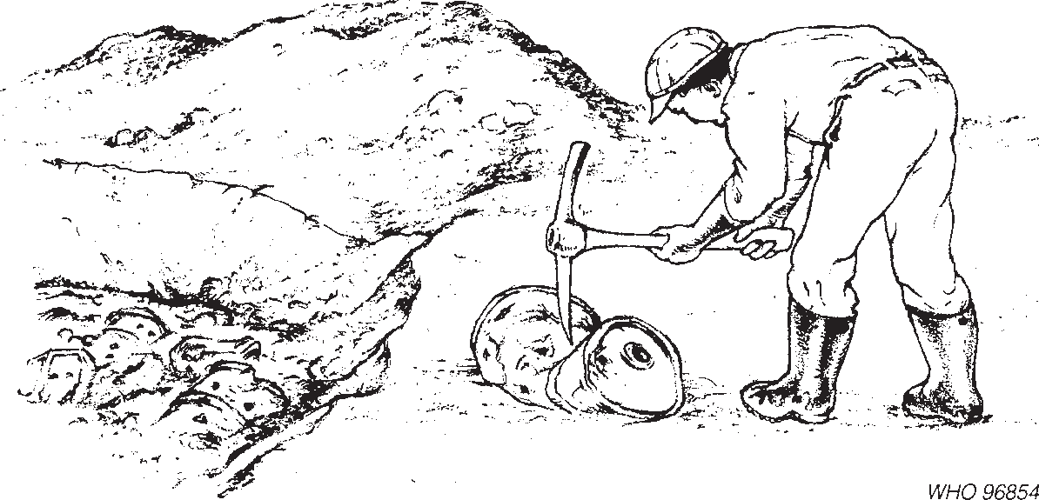

**Fig. 10.5**

Packages to be buried must be made unusable and reduced in bulk as much as possible (adapted from *4*).

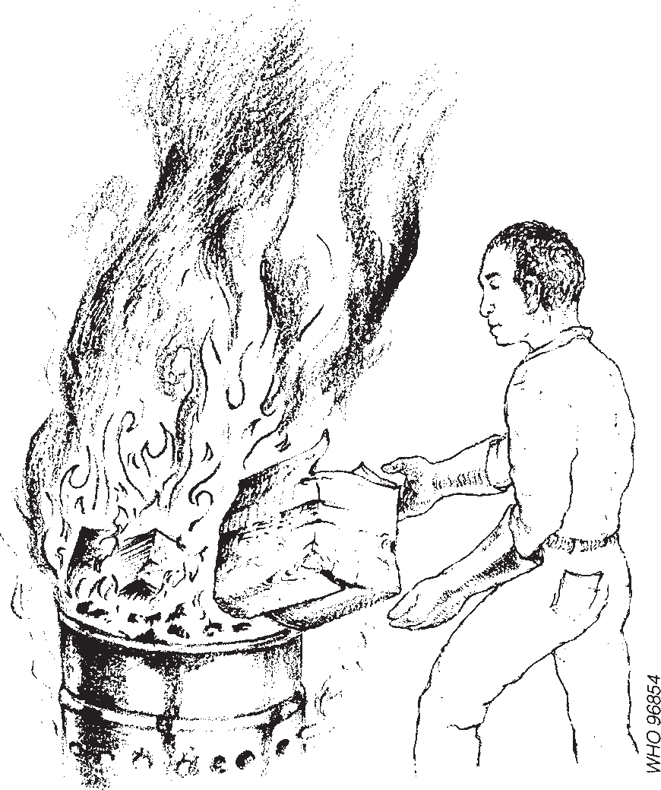**Fig. 10.6**

Clean paper and cardboard and cleaned plastic containers (not PVC) may be burnt (adapted from *4*).

mosquitos from biting from below. Where bedbugs are a problem, mattresses can be treated.

**Cleaning used pesticide containers**

The reuse of pesticide containers is risky and not recommended. However, some pesticide containers may be considered too valuable to be thrown away after use. Whether containers are suitable for cleaning and reuse depends on the material they are made of and what they contained. The label should provide instructions on possibilities for reuse and cleaning proce- dures.

Containers that have held pesticide formulations classiﬁed as highly hazardous or extremely hazardous must not be reused. Under certain conditions, containers of pesticide formulations classiﬁed as slightly hazardous or unlikely to present acute hazard in normal use can be reused for purposes other than the storage of food, drink or animal feed. Containers made of materials such as polyethylene that preferentially absorb pesticide should not be reused if they have held pesticides in which the active ingredient is classiﬁed as moderately, highly or extremely hazard- ous, regardless of the formulation.

Pesticidecontainersshouldberinsedassoonastheyareempty,completelyﬁlledwithwater,and allowedtostandfor24hours.Theyshouldthenbeemptied,andtheprocessrepeatedtwice.

## General hygiene

Do not eat, drink or smoke while using insecticides. Keep food in tightly closed boxes. Use suitable equipment for measuring out, mixing and transferring insec-

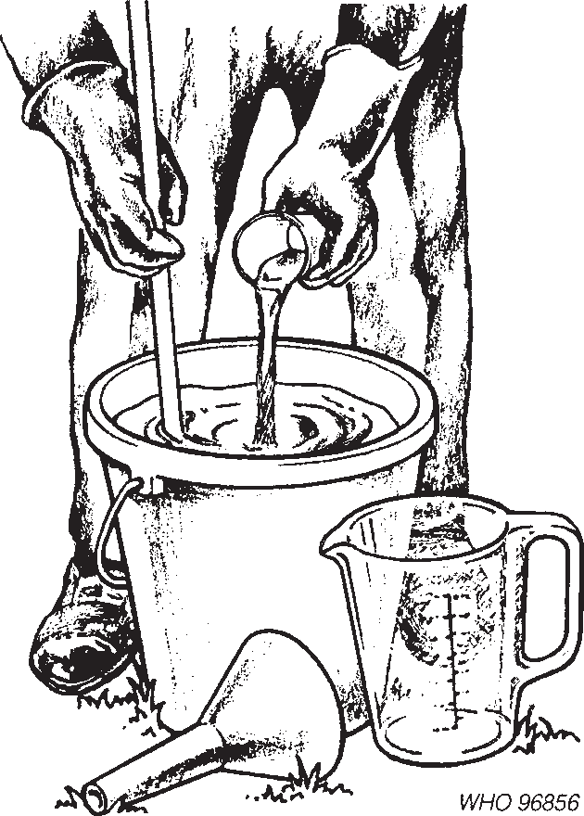**Fig. 10.7**

Use suitable equipment for measuring out and mixing insecticides (adapted from *2*).

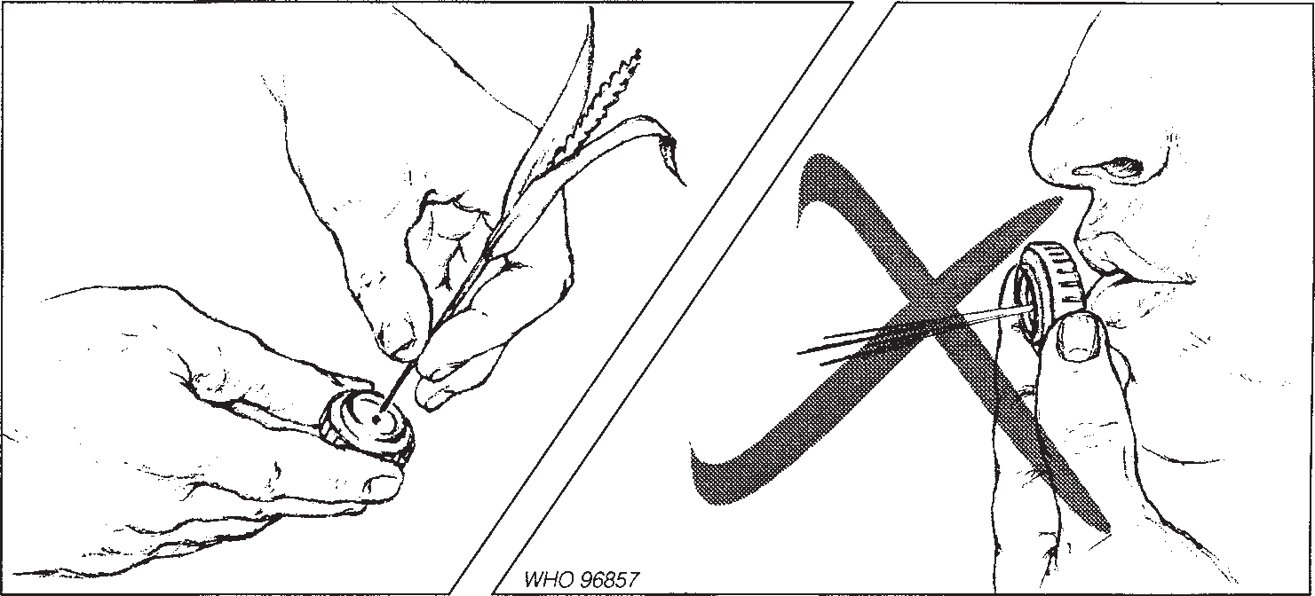

**Fig. 10.8**

Clean blocked nozzles with a soft probe (adapted from *2*).

ticides(Fig.10.7).Donotstirliquidsorscooppesticidewithbarehands.Usethe pressure-releasevalveofthepumporasoftprobetoclearblockagesinthenozzle (Fig. 10.8; see also Chapter 9, p. 379). Wash the hands and face with soap and water each time the pump has been reﬁlled. Eat and drink only after washing the handsandface(Fig.10.9).Takeashowerorbathattheendoftheday.

## Protective clothing

### Spraying indoors

Spray workers should wear overalls or shirts with long sleeves and trousers, a broad-brimmedhat,aturbanorotherheadgearandsturdyshoesorboots.Sandals

are unsuitable. The mouth and nose should be covered with a simple devicesuch as a disposable paper mask, a surgical-type disposable or washable mask, or any clean piece of cotton. The cotton should be changed if it becomes wet. The clothing should be of cotton for ease of washing and drying. It should cover the body without leaving any openings. In hot and humid climates the wearing of additionalprotectiveclothingmaybeuncomfortable,andpesticidesshouldthere- forebeappliedduringthecoolerhoursoftheday.

### Mixing

People who mix and pack insecticides in bags must take special precautions (see Chapter 9, p. 373). In addition to the protective clothing described above, it is recommended that gloves, an apron and eye protection such as a face shield or goggles be worn (Figs. 10.10 and 10.11). Face shields provide protection for the whole face and are cooler to wear. The mouth and nose should be covered, as

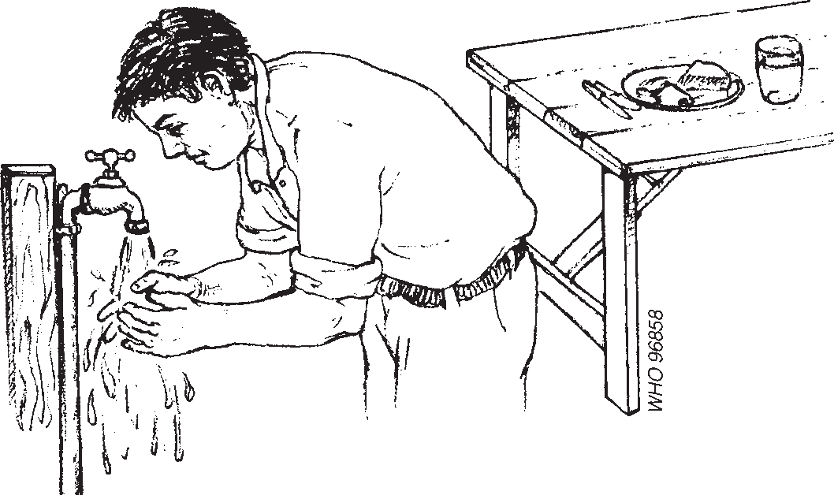

**Fig. 10.9**

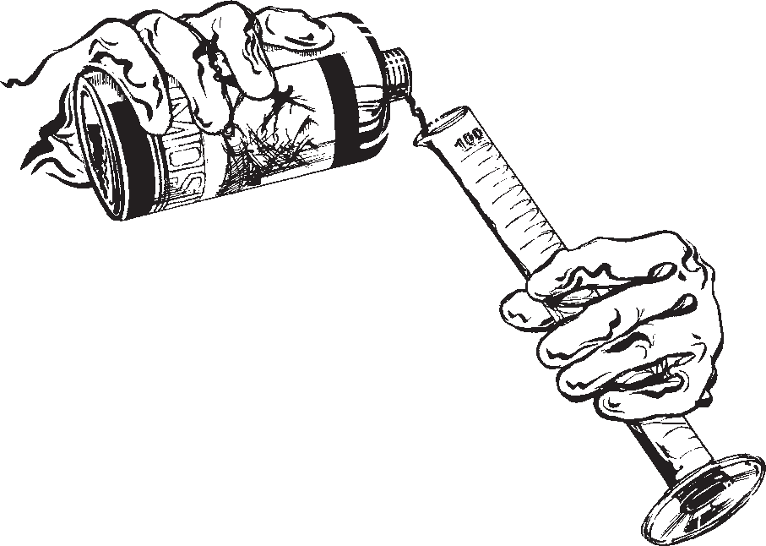Wash the hands and face before eating or drinking (adapted from *2*).

**Fig. 10.10**

Wear gloves when handling concentrates.

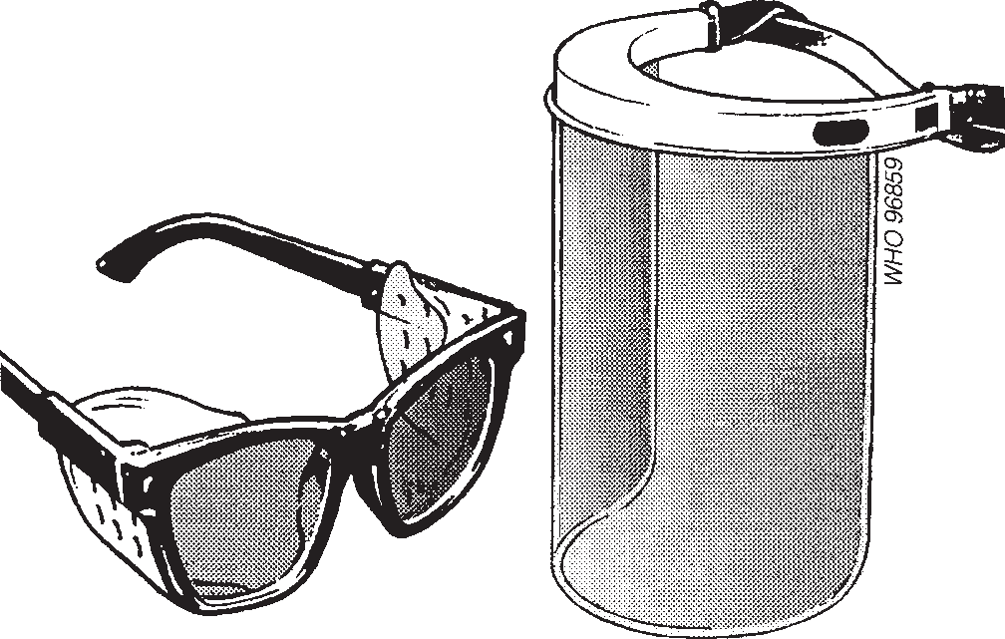**Fig. 10.11**

Protective equipment for the eyes and face (adaptedfrom *2*).

recommended for indoor spraying. Care should be taken not to touch any part of the body with gloves while handlingpesticides.

### Impregnation of fabrics

Longrubberglovesshouldbewornwhentreatingmosquitonets,clothes,screen- ing or tsetse traps withinsecticides.

Under certain circumstances extra protection may be required, e.g. from vapour, dust or spray of hazardous products. Such additional protective items should be indicated on the product label and may include aprons, boots, face masks, overalls and hats.

### Maintenance

Clothingshouldbekeptinagoodstateofrepairandshouldbeinspectedregularly fortearsorwornareasthroughwhichskincontaminationmightoccur.Protective clothing and equipment should be washed daily with soap, separately from other clothing. Gloves need special attention and should be replaced when there isany signofwearandtear.Afteruse,glovesshouldberinsedwithwaterbeforetheyare taken off. At the end of each working day they should be washed inside and outside.

## Safe techniques

### Spraying

The discharge from the sprayer should be directed away from the body. Leaking equipmentshouldberepairedandtheskinshouldbewashedafteranyaccidental contamination. Persons and domestic animals must not remain indoors during spraying. Rooms must not be sprayed if someone, e.g. a sick person, cannot be moved out. Cooking utensils, food and drinking-water containers should be put outdoorsbeforespraying.Alternatively,theycanbeplacedinthecentreofaroom and covered with a plastic sheet (Fig. 10.12). Hammocks, paintings and pictures must not be sprayed. If furniture has to be sprayed on the lower side and theside nexttoawall,careshouldbetakentoensurethatothersurfacesarenotleft

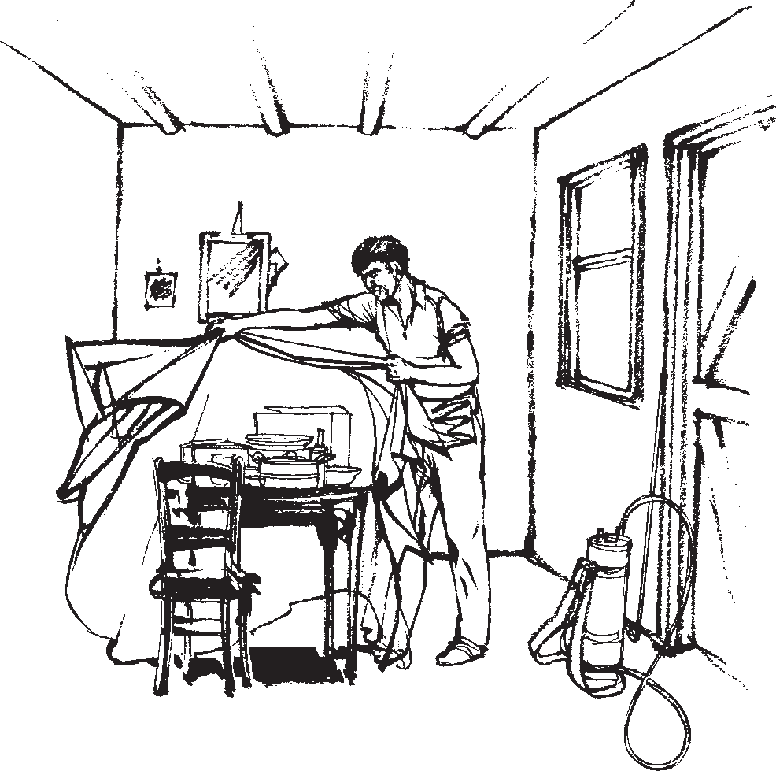

**Fig. 10.12**

Furniture and food should be covered with a plastic sheet or placed outdoors before a house is sprayed.

unsprayed. Floors should be swept clean or washed after spraying. Inhabitants should avoid contact with the walls. Clothes and equipment should be washed daily.

Organophosphorusandcarbamatecompoundsshouldnotbeappliedformore than 5–6 hours a day and the hands should be washed after every pump charge. Blood cholinesterase activity of spray personnel should be checked weekly if fenitrothionoroldstocksofmalathionareused(seebox).

**Monitoring exposure to organophosphorus compounds**

Commercial ﬁeld kits are available for monitoring blood cholinesterase activity. Low levels suggest overexposure to an organophosphorus insecti- cide. Such assays should be performed weekly for all persons handling theseproducts.Personswithundulylowcholinesteraseactivityshouldstop workingwithinsecticidesuntilithasreturnedtonormal.

### Impregnation of fabrics

Gloves should be worn when handling the insecticide concentrate and preparing the insecticide mixture. Care should be taken to avoid splashing insecticide into the eyes. A wide, shallow bowl should be used (Fig. 10.13), and the room should bewell-ventilatedtoavoidfumesbeinginhaled.

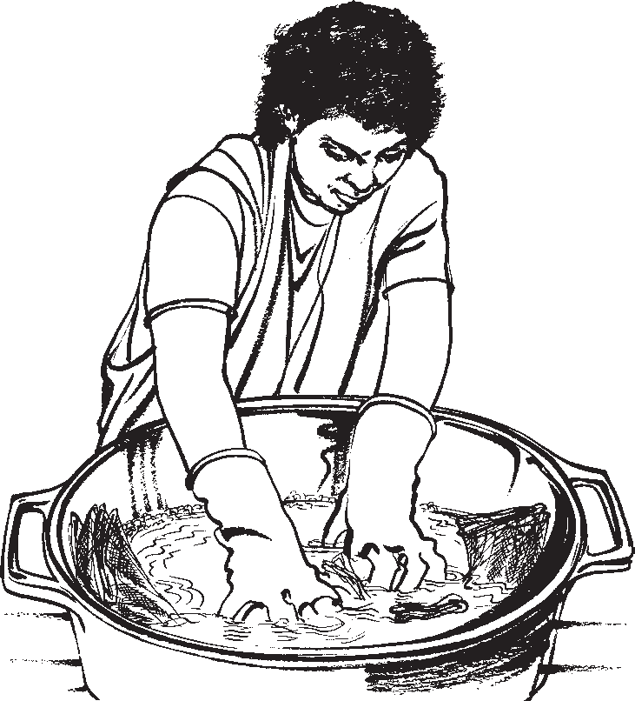**Fig. 10.13**

Wear long rubber gloves and use a wide, shal- low bowl when impregnating fabrics.

# Emergency measures

## Signs and symptoms ofpoisoning

Poisonings due to pesticides are usually acute and result from extensive skin contact or ingestion. Signs and symptoms vary with the type of pesticide and can sometimesbeconfusedwiththoseofotherillnesses.

### Indications of pesticide poisoning

*General*: extreme weakness and fatigue.

*Skin*: irritation, burning sensation, excessive sweating, staining.

*Eyes*:itching,burningsensation,watering,difﬁcultorblurredvision,narrowedor widenedpupils.

*Digestive system*: burning sensation in mouth and throat, excessive salivation, nausea, vomiting, abdominal pain, diarrhoea.

*Nervous system*: headaches, dizziness, confusion, restlessness, muscle twitching, staggering gait, slurred speech, ﬁts, unconsciousness.

*Respiratory system*: cough, chest pain and tightness, difﬁculty with breathing, wheezing.

It is important to obtain additional information:

Has the patient been working with a pesticide? Did contamination occur?

•

Precisely which product was used? How much was ingested?

•

•

How long ago?

An effort should be made to obtain evidence from pesticide containers or spray equipment; the labels on containers should be read and retained.

If pesticide poisoning is suspected, ﬁrst aid must be given immediately and medicaladviceandhelpmustbesoughtattheearliestopportunity.Ifpossible,the patientshouldbetakentothenearestmedicalfacility.

## First-aidtreatment

**Ifbreathinghasstopped:**Giveartiﬁcialrespiration.Ifnoinsecticidehasbeen swallowed,mouth-to-mouthresuscitationmaybegiven.Pullthepatient’schinup andtilttheheadbackwithonehandtokeeptheairwayclear.Placetheotherhand onthepatient’sforehead,withthethumbandindexﬁngertowardthenose.Pinch togetherthepatient’snostrilswiththethumbandindexﬁngertopreventairfrom escaping. Take a deep breath, then form a tight seal with your mouth over and around the patient’s mouth (Fig. 10.14). Blow four quick, full breaths in ﬁrst withoutallowingthelungstodeﬂatefully.Watchthepatient’schestwhileinﬂating the lungs. If adequate respiration is taking place, the chest should rise and fall. Remove your mouth and allow the patient to breathe out (Fig. 10.15). Take another deep breath, form a tight seal around the patient’s mouth, and blow into the mouth again. Repeat this procedure 10–12 times a minute (once every ﬁve seconds).

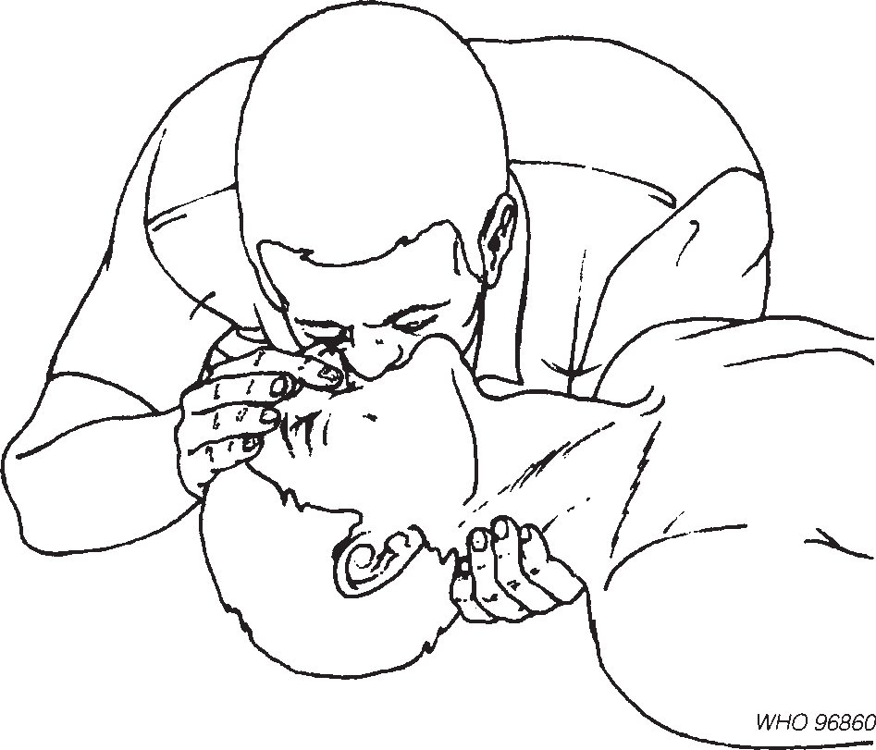**Fig. 10.14**

Mouth-to-mouth resuscitation. Take a deep breath, thenform a tight seal with your mouth over and around the patient’s mouth (© WHO).

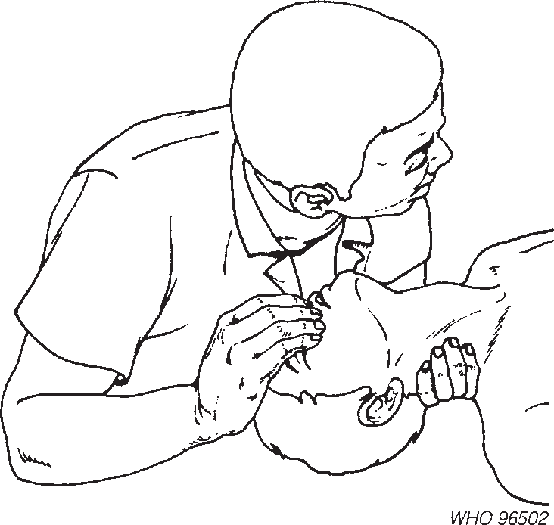**Fig. 10.15**

Mouth-to-mouth resuscitation. Remove your mouth and allow the patient to breathe out (© WHO).

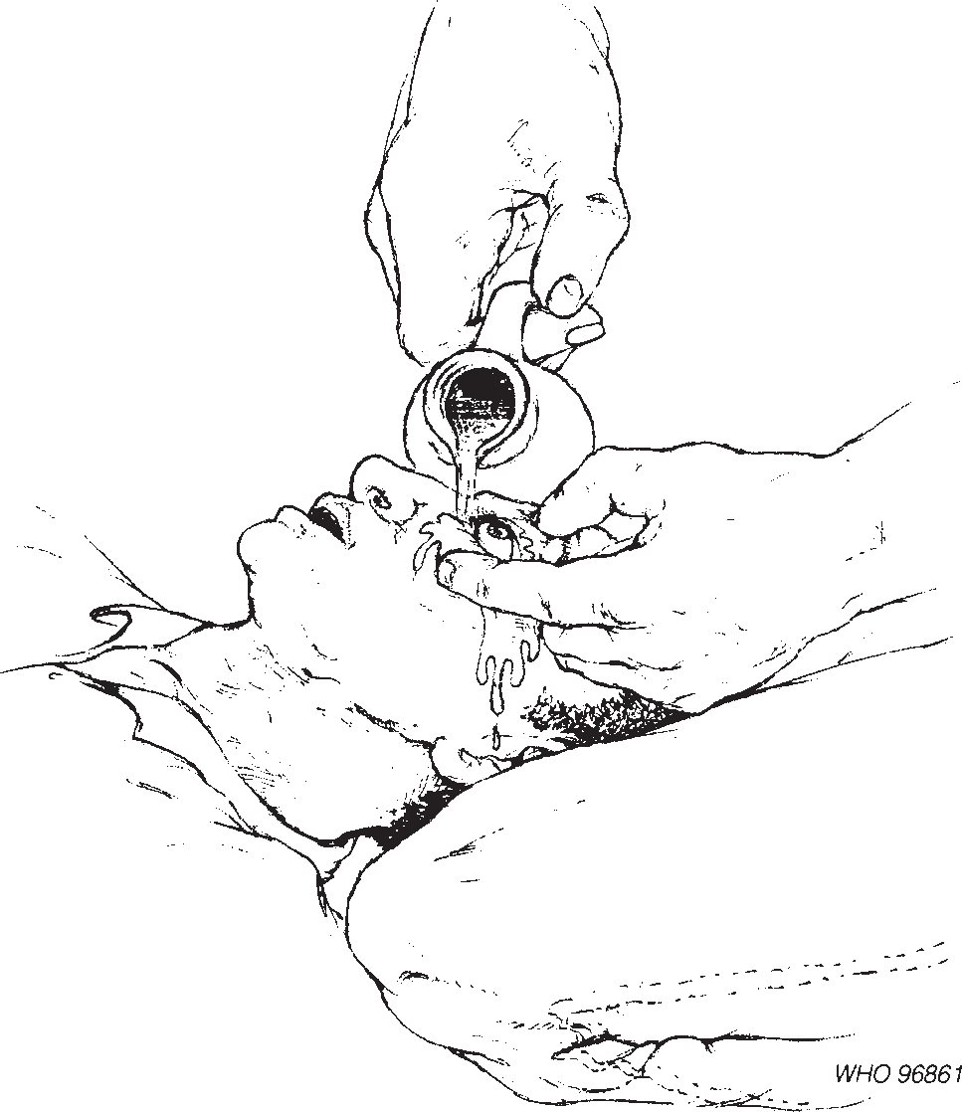

**Fig. 10.16**

Wash pesticide splashes from the eyes with clean water for at least ﬁve minutes (adapted from *3*).

Artiﬁcial respiration should be continued for as long as possible if there is still a pulse. If insecticide has been swallowed, another form of artiﬁcial ventilation should beused.

**Ifthereisinsecticideontheskinorintheeyes:**Rinsetheeyeswithlarge quantities of clean water for at least ﬁve minutes (Fig. 10.16). Remove contami- nated clothing from the patient and remove the patient from the contaminated area (Fig.10.17).

Wash the body completely for at least 10 minutes, using soap if possible. If no water is available, wipe the skin gently with cloths or paper to soak up the pesticide. Avoid harsh rubbing or scrubbing.

### Vomiting

Do not induce vomiting unless the patient has swallowed pesticide that isknown tobehighlytoxic,andmedicalhelpisnotexpectedsoon.Neverinducevomiting if the patient has swallowed oil spray or products diluted in diesel or kerosene, because of the possibility of inhalation of the vomited material, which would be more dangerous than the intestinal poisoning. The product label should indicate whetherthepesticideishighlytoxic(skull-and-crossbonessigns).Vomitingshould beinducedonlyifthepatientisconscious.Ifnecessary,sitorstandthepersonup and tickle the back of the throat with a ﬁnger. Whether vomiting occurs or not, give the patient a drink comprising three tablespoonfuls of activated charcoal in halfaglassofwater.Repeatuntilmedicalhelparrives.

### Caring for the patient

Makethepatientliedownandrestbecausepoisoningwithorganophosphorusand carbamatecompoundsismadeworsebymovement.Placethepatientonherorhis sidewiththeheadlowerthanthebody.Ifthepatientisunconscious,pullthechin forwardandtheheadbacktoensureaclearairway(Fig.10.18).Coverthepatient with a blanket if he or she feels cold, and cool the patient by sponging with cold waterifexcessivesweatingoccurs.Ifthepatientvomitsspontaneously,ensurethat he or she does not inhale the vomit. In the event of convulsions, put padded material between the teeth to avoidinjury.

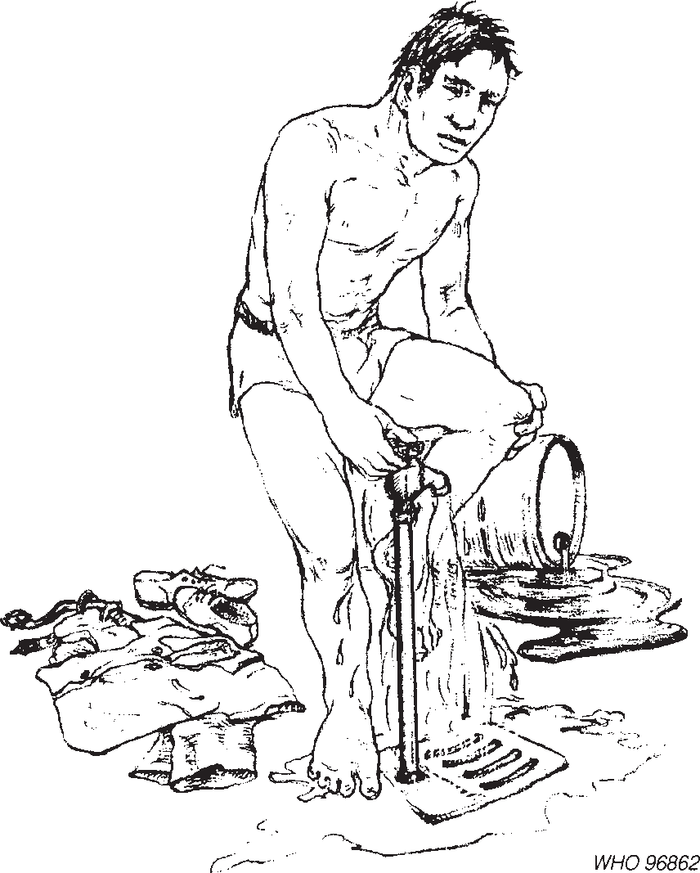**Fig. 10.17**

Remove contaminated clothing immediately and wash the skin (adapted from *3*).

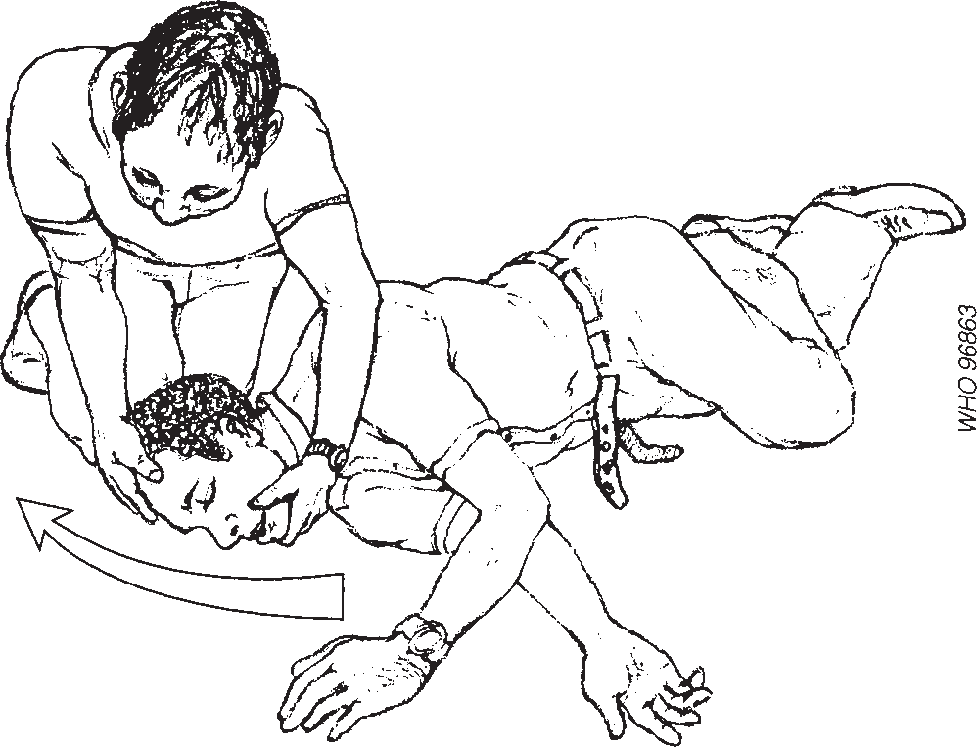**Fig. 10.18**

Place an unconscious pa- tient on her or his side and tilt the head back (adapted from *5*).

Do not allow patients to smoke or drink alcohol. Do not give milk. Water can be given.

## Further treatment

Patients requiring further medical treatment should be referred to the nearest medical facility. Detailed guidelines for the management of poisoning are being prepared by WHO (*6*). A list of poisons information centres is also available on request (*7*).

# References

1. *Speciﬁcationsforpesticidesusedinpublichealth:insecticides,molluscicides,repellents,methods*, 6thed.Geneva,WorldHealthOrganization,1985.
2. *Guidelinesforpersonalprotectionwhenusingpesticidesinhotclimates*.Brussels,International GroupofNationalAssociationsofManufacturersofAgrochemicalProducts,1989.
3. *Guidelines for the safe and effective use of pesticides*. Brussels, International Group of NationalAssociationsofManufacturersofAgrochemicalProducts,1989.
4. *Guidelinesfortheavoidance,limitationanddisposalofpesticidewasteonthefarm*.Brussels, International Group of National Associations of Manufacturers of Agrochemical Prod- ucts,1987.
5. *Guidelines for emergency measures in cases of pesticide poisoning*. Brussels, International GroupofNationalAssociationsofManufacturersofAgrochemicalProducts,1984.
6. HenryJ,WisemanH.*Managementofpoisoning:ahandbookforhealthcareworkers.*

Geneva, World Health Organization, in press.

1. International Programme on Chemical Safety/World Federation of Associations of ClinicalToxicologyCentresandPoisonControlCentres.*YellowTox.Worlddirectoryof poisons centres.* Geneva, World Health Organization, 1993 (unpublished document; available on request from the International Programme on Chemical Safety, World Health Organization, 1211 Geneva 27,Switzerland).

# Selected further reading

*Guidelines for the safe handling of pesticides during their formulation, packing, storage and transport*.Brussels, International Group of National Associations of Manufacturers of Agrochemical Products, 1982.

International Programme on Chemical Safety.*The WHO recommended classiﬁcation of pesticides by hazard and guidelines to classiﬁcation 1994–1995*. Geneva, World Health Organi- zation, 1994 (unpublished document WHO/PCS/94.2; available onrequest from Programme for the Promotion of Chemical Safety, World Health Organization, 1211Geneva 27,Switzerland).

*Safeuseofpesticides.FourteenthreportoftheWHOExpertCommitteeonVectorBiologyand Control.*Geneva, World Health Organization, 1990 (WHO Technical Report Series, No. 813).